Write an Algorithm for Calculator

Step 1 – Start

Step 2 – Get Inputs from user (a,b) – Get 2 numbers from user (a & b)

Step 3 (If radio button 1 is clicked) – Add Two Numbers

Step 3 (If radio button 2 is clicked) – Subtract Two Numbers

Step 3 (If radio button 3 is clicked) – Multiply Two Numbers

Step 3 (If radio button 4 is clicked) – Divide Two Numbers

Step 3 (If radio button 5 is clicked) – Find the remainder

Step 4 – Print Answer - Outcome

Step 5 – Stop

Draw Flowchart for Calculator

Starts the program

Input(a,b)

Input 2 numbers (A and B)

Radio Button 1 is clicked

If Radiobutton 1 is clicked(true)

c=a+b

Adds number 1 and 2

If false, go to next.

c=a-b

Radio Button 2 is clicked

If radiobutton 2 is clicked(true) subtracts number 1 from 2

If false, go to next.

Radio Button 3 is clicked

c=a*b

If radiobutton 3 is clicked(true) multiplies number 1 with 2

If false, go to next.

Radio Button 4 is clicked

c=a/b

If radiobutton 4 is clicked(true) divides number 1 with 2

If false, go to next.

Radio Button 5 is clicked

Finds the remainder

c=a%b

If radiobutton 5 is clicked(true

print(c)

Print outcome

Ends the program

Calculator

|  |  |
| --- | --- |
| Repository Name | Repository Link |
| calculator | https://github.com/HansLiamCabrieto/Calculator |
| Google docs | <https://docs.google.com/document/d/1ELmTGvYlTV_uvMHbf_X0VwEJC16zTbnEfNgGEExADgo/edit?usp=sharing> |
|  |  |

using System;

using System.Collections.Generic;

using System.ComponentModel;

using System.Data;

using System.Drawing;

using System.Linq;

using System.Text;

using System.Threading.Tasks;

using System.Windows.Forms;

namespace Calculator

{

public partial class Form1 : Form

{

public Form1()

{

InitializeComponent();

}

private void label2_Click(object sender, EventArgs e)//tool

{

}

private void textBox1_TextChanged(object sender, EventArgs e)//tool

{

}

private void textBox2_TextChanged(object sender, EventArgs e)//tool

{

}

private void radioButton1_CheckedChanged(object sender, EventArgs e)//tool

{

}

private void radioButton2_CheckedChanged(object sender, EventArgs e)//tool

{

}

private void radioButton3_CheckedChanged(object sender, EventArgs e)//tool

{

}

private void radioButton4_CheckedChanged(object sender, EventArgs e)//tool

{

}

private void radioButton5_CheckedChanged(object sender, EventArgs e)//tool

{

}

private void button1_Click(object sender, EventArgs e)//tool

{

int a = 0 + Convert.ToInt32(textBox1.Text);//collects and saves number 1 as a

int b = 0 + Convert.ToInt32(textBox2.Text);//collects abd saves number 2 as b

int c;//The Answer

if (radioButton1.Checked)//checks at radion button 1 is checked

{

c = a + b;//The answer will be a+b

label4.Text = "Total = " + c.ToString();//Prints answer to label 4

}

else if (radioButton2.Checked)//Checks if radio button 2 is checked

{

c = a - b;//The answer will be a-b

label4.Text = "Difference = " + c.ToString();//Prints answer to label 4

}

else if (radioButton3.Checked)//Checks if radio button 3 is checked

{

c = a * b;//The answer will be a*b

label4.Text = "Product = " + c.ToString();//Prints answer to label 4

}

else if (radioButton4.Checked)//Checks if radio button 4 is checked

{

c = a / b;//the answer will be a/b

label4.Text = "Quotient = " + c.ToString();//Prints answer to label 4

}

else if (radioButton5.Checked)//Checks if radio button 5 is checked

{ c = a % b;//The answer will be a%b

label4.Text = "Remainder = " + c.ToString();//Prints answer to label 4

}

else

{ label4.Text = "Please Choose one of the Options";//Prints to label 4 if nothing is checked

}

}

private void button2_Click(object sender, EventArgs e)//tool

{

label4.Text = "Answer";//Changes label 4 to "Answer"

textBox1.Clear();//Clears textbox 1

textBox2.Clear();//clears textbox 2

}

private void button1_MouseHover(object sender, EventArgs e)//tool

{

button1.BackColor = Color.Green;//Changes button color to Green when mouse hovers on button 1

}

private void button1_MouseLeave(object sender, EventArgs e)//tool

{

button1.BackColor = Color.White;//Changes button color to white when mouse leaves button 1

}

private void button2_MouseHover(object sender, EventArgs e)//tool

{

button2.BackColor = Color.Red;//Changes button color to red when mouse hovers on button 2

}

private void button2_MouseLeave(object sender, EventArgs e)//tool

{

button2.BackColor = Color.White;//Changes button color to white when mouse leaves button 2

}

}

}

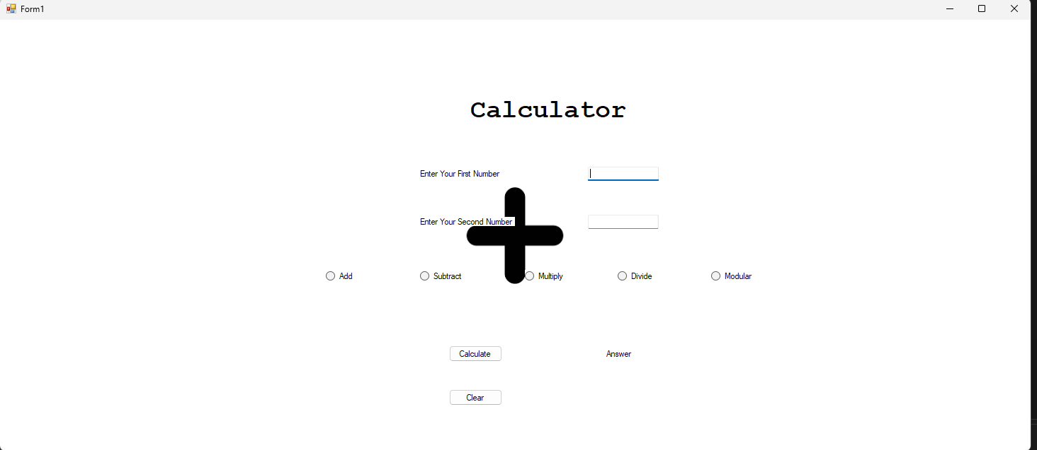Screenshot of layout

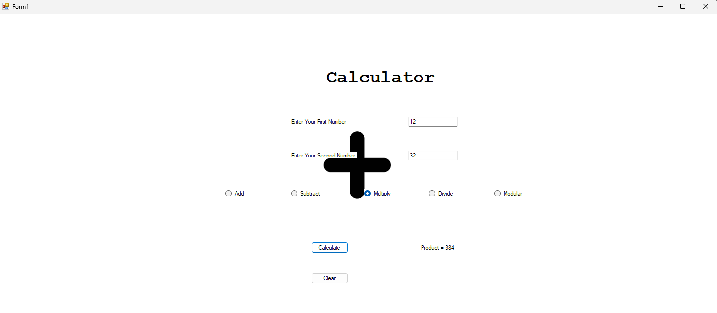Multiply (12*32)

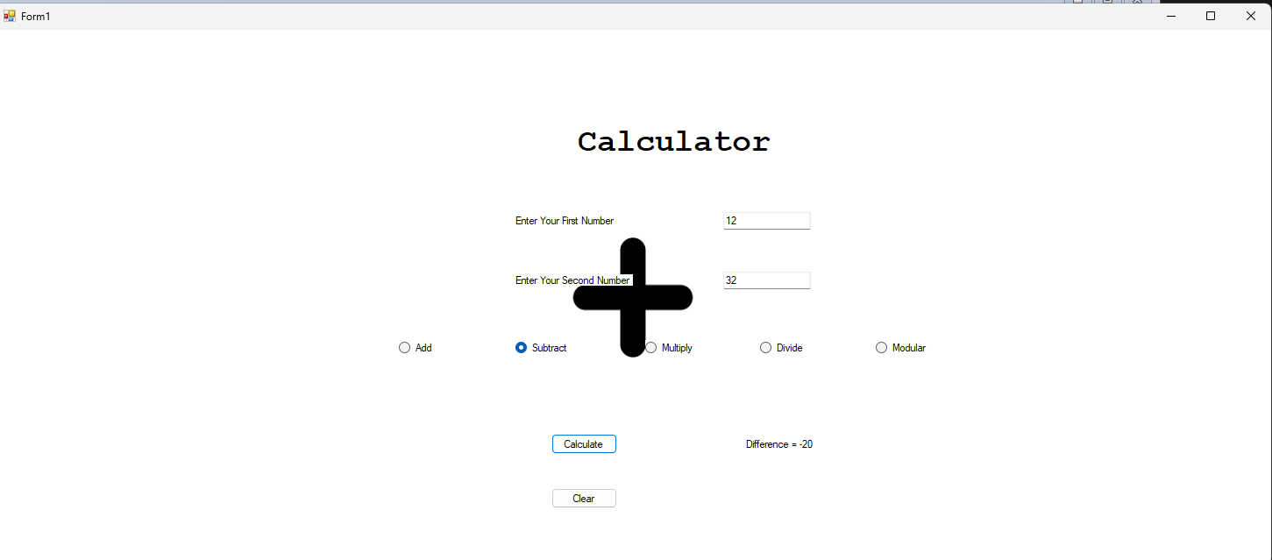Subtract (12-32)

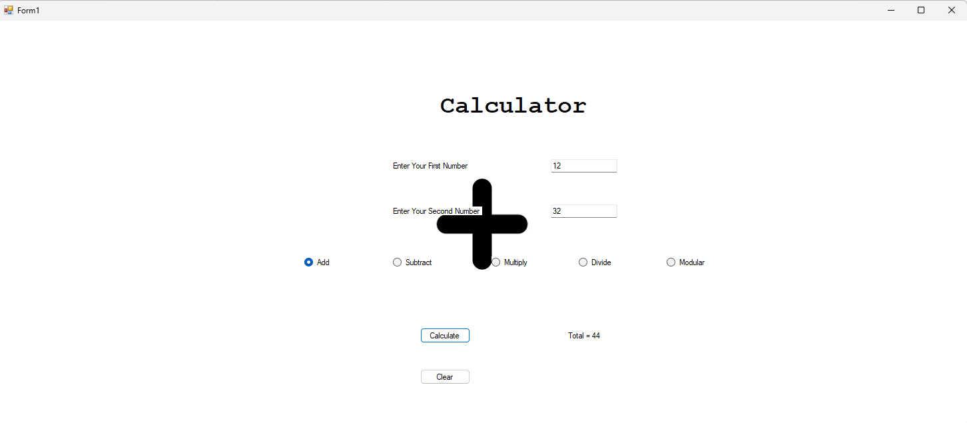Add (12+32)

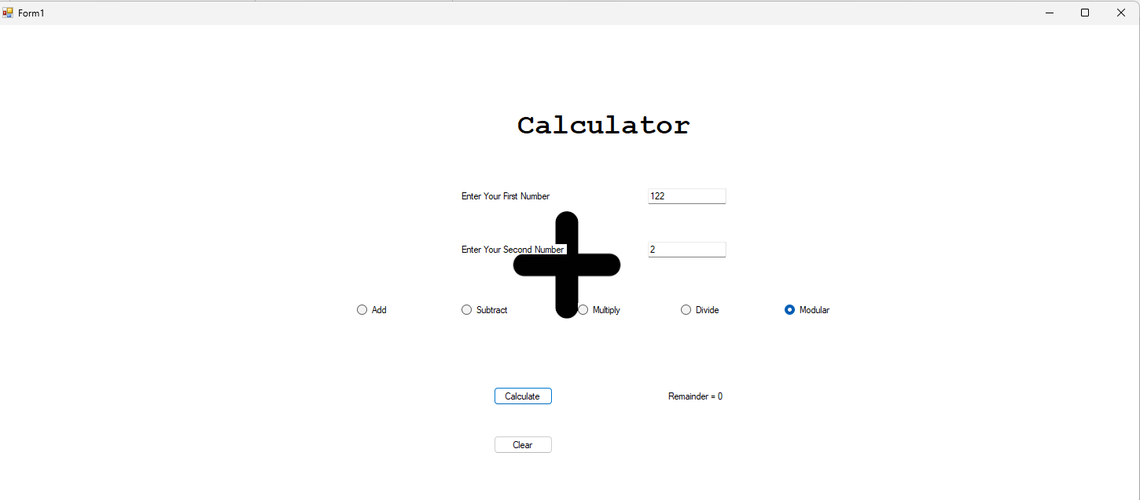Modular (122%2)

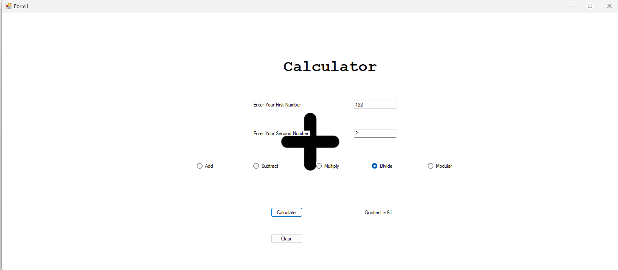Divide (122/2)

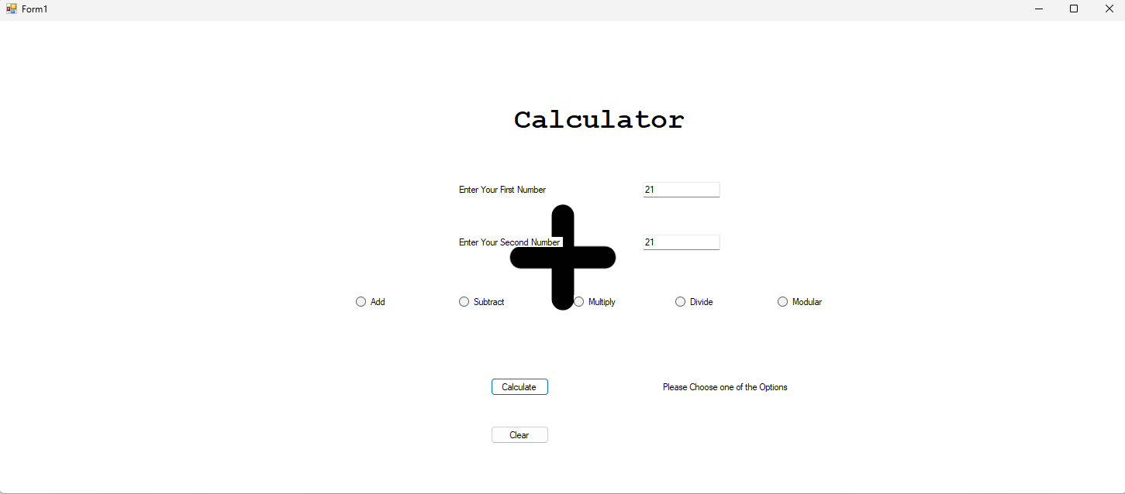

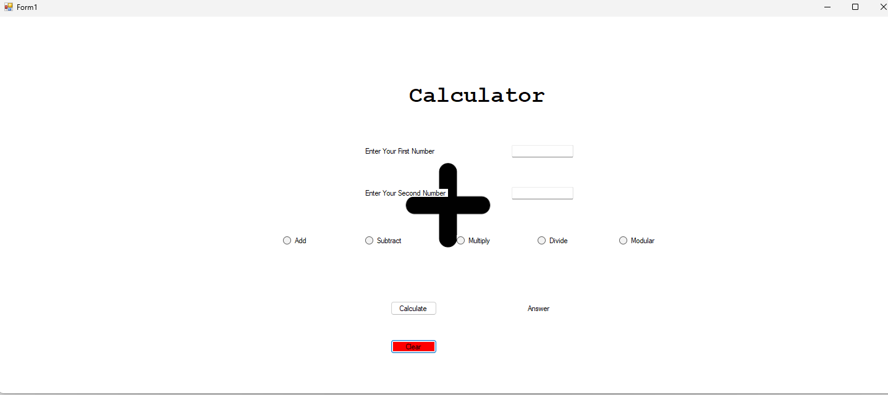Clear